Freelance job portal

recommendation engine

Business Document

Date: 09th November 2020

# Table of contents

Page no.

1. Introduction 3

2. The hiccups 4

3. Revenue analysis 6

4. Solving major concerns 11

5. Competition analysis 17

6. Relevant analysis 21

7. Solution - recommendation engine 22

8. System architecture 23

# Introduction

W

hatever be the skillset, there’s always a job that can be found online. Welcome to the digital nomad culture that’s on the rise, more and more people are becoming independent and self-employed leading to the rise of freelancing. One doesn’t need to have a million-dollar idea or billion-dollar funding, all one needs is the right skillset.

The freelancing industry is probably safe to be presumed as one of the pillar of modern society. Many on-demand services would have been inexistent if not for freelancers. Freelancing and on-demand services enable micromanagement of time and resources leading to tremendous savings in terms of money and time.

According to a [report by Deloitte](https://www2.deloitte.com/us/en/insights/focus/technology-and-the-future-of-work/millennials-in-the-gig-economy.html), it is estimated that as of now those who do freelance gigs earn less than their full time employed counterparts. Uber in 2014 claimed that their cab drivers on an average make around $91000 per annum but a [survey by Ridester](https://www.ridester.com/2018-survey/) suggests they earn only $14.73 per hour on an average.

Former U. S. Secretary of labor, Robert Reich, estimates that within a few years, 40 percent of the U. S. Workforce will be comprised of independent contractors and within a decade, most of the workforce will fit in that category. In fact, a report by Upwork and Freelancers union suggests that by 2027, the majority of the workforce in the US will be freelancers. (Source: [Forbes](https://www.forbes.com/sites/davidpetersson/2018/10/27/the-problems-with-freelancing-and-how-blockchain-can-help/%234624d2fe7b8d))

Things are no different in India either, it is estimated that by end of 2020, 50% of India’s workforce will fit bill to be categorised as freelancers. (Source: [YourStory](https://yourstory.com/2019/06/best-freelance-jobs-websites))

# The hiccups

W

hile there is evident growth in the number of freelancers and the number of portals cropping up providing wider scope for freelancers, it does come with its fair share of issues. Here, we discuss various problems faced by clients, as in job posters, and freelancers.

1. Excess applicants and difficult to filter out the right ones
2. Very low value for job takers of late as competition is leading to lower priced bids.
3. Charging cost per connect on platforms like upwork makes it even less valuable for freelancers.
4. Not worth writing custom covering letters and proposals due to lowering margins for freelancers
5. Charging fee to connect might give access to inefficient freelancers and make it difficult for clients to choose the right freelancer.
6. Freelancer allows max 8 bids per month in free tier and fiverr allows 10 per day so it’s even more important to choose the right works.
7. Good freelancers are established on some platforms and don’t migrate to other platforms.
8. Too much spam/fake/non-serious job listings killing the experience as it is free for clients to post jobs.
9. As no fees, even many genuine clients don’t finalise projects eventually leading to a deadlock. Yes, some freelancers charge a lot but some charge very less even with great number of good reviews.
10. Stiff competition making it difficult to get jobs
11. Getting job posters on board is difficult for new platforms
12. Suspension of accounts if no jobs are secured in a year on platforms like UpWork making it essential to get at least some successful jobs for freelancers.

Most of the issues faced by freelancers as well as clients can be solved with personalised recommendations that can help filter in only the relevant freelancers or clients for each other and ensuring more success rate in finalising jobs.

# Revenue Analysis

1. UpWork

Analysing the revenue of UpWork, we can see that revenue from marketplace forms a major part of their revenues. The marketplace revenues raked up to USD 74,782,000 in the second quarter of 2020 which constitutes 90% of the total earned revenue. They have witnessed a growth of profit by 26% when their marketplace revenue grew by 24% from Q2 2019 to Q2 2020 compared. This shows the prominence of marketplace revenues.

2. Fiverr

Fiverr has only one major source of revenue, that’s the 20% commission they earn on any job sold by their registered businesses. We can see that a spike in revenue from Q2 2019 to Q2 2020 which was 85% led to a major growth in profit as well, which was 90%, as their cost of revenue is still limited. We might conclude that if a recommendation engine can help them achieve higher revenues that will lead to a much higher growth in gross profit as well.

3. Freelancer.com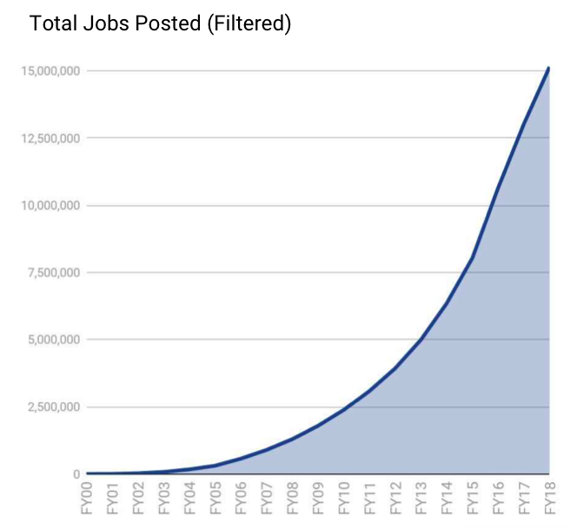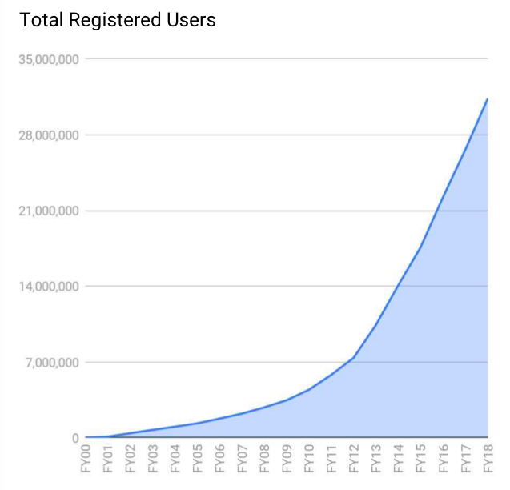

Looking into the financial report published by Freelancer.com in 2019, we can infer that their registered user base and total job posted has grown exponentially from 2010 to 2018 but looking at their revenue generated, there is a stagnation of year on year growth over the past three years.

There are multiple reason that lead to revenue stagnation

1. Stagnated number of jobs finalised
2. Increasing expenses with increasing revenue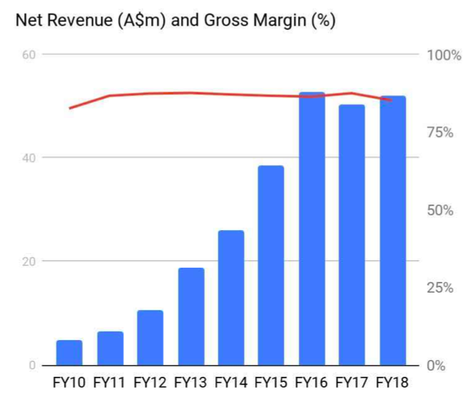

An implementation of recommendation engine can ensure the problem of stagnated number of jobs finalised be resolved to a certain extent. Providing better recommendations to freelancers as well as clients might increase the probability of finalising a job effectively thus helping freelancer.com generate more revenue.

Other competitors:

1. Guru
2. People per hour
3. Urban pro
4. Broxer
5. Listverse
6. Contentwriters
7. Crowd content
8. Behabce
9. Dribble
10. Codeable
11. 99 Designs
12. Gradbee
13. Stumagz

# Solving Major Concerns

The early positive impact of the emergence of two-sided talent platforms

on freelancers has started to slowly erode due to three trends:

1. The **“atomization” of the talent platform staffing** process from one managed by highly skilled ex-consultants to one mostly outsourced directly to the freelancer
2. The **proliferation of new talent platforms** due to the zero marginal cost economics of a talent platform
3. The **incentives of VC-backed talent platforms** which prioritizes firm-level growth while ignoring the health of the overall ecosystem

**Issue #1: Talent platforms have “atomized” the talent staffing process and outsourced much of the work to an unpaid freelancer labor force.**

Around the year 2000, the original consulting talent platforms started to emerge. These companies, *Talent Platform 1.0 Companies,* offered projects to freelancers and in return asked for very little. If you were part of their vetted pool of talent and the right fit, just show up and start working.

These early talent platforms were “closed” platforms meaning that clients did not have visibility into the talent pool and the talent pool could not see the projects in progress or in the pipeline.

These firms were very hands-on, spending time building client relationships, sourcing and validating projects and scoping them so they were ready to go when the consultant was staffed. These firms employed highly-skilled ex-consultants and talent executives that understood how to staff projects and execute on complex consulting engagements. Both the clients and consultants were happy to let these firms capture 30–40% margins for all of this value that they offered.

The internal process was labor-intensive and depended on highly customised relationships with each client. These original platforms all explored opportunities for efficiency through having freelancers write their own proposals or debating easier ways for clients to submit projects, but they never really fit with the underlying business model.

Now, this kind of shift would have undermined the goals of the firms, whose success was dependent on building long-term relationships with clients and offering a world-class talent experience during projects.

If we see from above diagram then in early ages platform and freelancer interaction with clients helped to make a strong relationship between platform and client and client were more satisfied.

So from here we can conclude that if we will include our recommended system to help the platform to select some best talent from the pool and provide to client then it will make good bonding between client and platform, which will let the platform to generate more reviews and also might be chance to get some incentives to platform due to good consultancy.

**Transparency! Talent Platform 2.0 Companies Show Up To The Party.**

This was a big shift and now I realize why the initial talent platforms could not make the shift so easily.

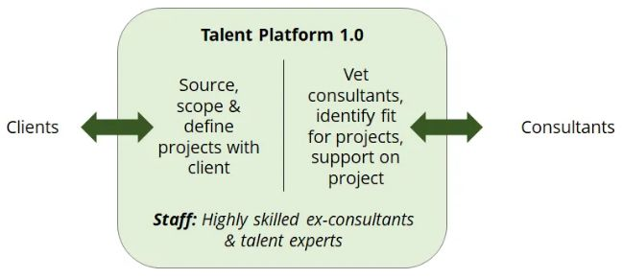 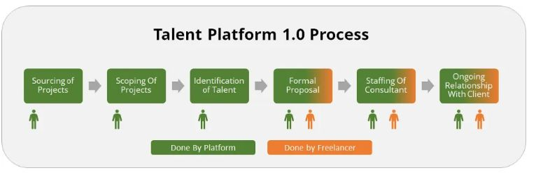

This shift was not simply increasing the visibility of projects and letting freelancers directly compete for projects. It was a shift from the structure of the talent platform as a hands-on talent agency to a hands-off technology company.

It meant a major difference in the types of employees these new talent platforms hired. Instead of experienced ex-strategy consultants who could help scope and manage complex projects, these new firms depended on people that had some understanding of talent and a deeper understanding of how to use technology.

So , now in this era this is a contribution of a platform and freelancer to perform on a project in a satisfactory manner. In this era clients as well as fresher freelancers are claiming that it’s not able to build good bonding with clients and talents.

**How will the recommended system solve this problem?**

So in this case recommended system will be helpful to find the best suited talents for client according to posted jobs, which will give the freedom to make strong bond with best recommended talent and clients satisfactory level will be uplifted by this, so indirectly platform bonding with the clients also increased which will definitely uplift the revenue of the platform.

**Issue #2: The lack of a “winner take all” platform means every additional platform created more work for the freelancer.**

In a market with few players, network effects start to take over and result in a winner-take-all zero-to-one dominant player.

However, no winner has emerged in the consulting talent platform space and this is bad for everyone. While the emergence of the first few platforms was incredible for the early freelancers

The high number of platforms leads to a few problems:

**i)** **First, there is no incentive for the freelancer or client to use any platform over another.** Harvard professors Feng Zhu and Macro Iansiti **call this** “multi-homing” which occurs when “users or service providers (network “nodes”) form ties with multiple platforms (or “hubs”) at the same time.”

**How recommended system may help this problem?**

Why, clients are not bound to our platform because there are no incentives or some offers provided to either clients or freelancers. In Fact it's difficult to give by platform without a recommended system because the platform is not aware of the best chunks of clients or freelancers. So here the recommended system will play an important role to select those clients projects and talent so that they can not churn to other platforms. Which will definitely uplift the revenue by making good bond with clients and talents.

**ii).** **Clients are incentivised to post any project,** no matter how likely they are to pursue that project. Clients can access experts and freelancers and get “free” consulting through initial pitches and conversations without the need to start an actual project.

**How will the recommended system solve this problem?**

Without a recommended system platform the above situation may arise because freelancers will give some incentives for further projects on the platform from backdoor. Because the platform has no means to show the other good talents which can give neck to neck competition to the previous talent. But platform with recommended system will help to think clients to communicate with other neck to neck competitors my be this time platform with recommended system help to find other talents on platform which will also uplifts the revenue of platform.

**Issue #3: A large amount of unpaid “busy work”**

for freelancers who wish to be in good standing and aware of the new projects appearing on the platforms. This work increases with the proliferation of platforms.

So , if we focus on quality of project then now days due to more involvement of consultancy and less involvement of platform lowered the quality of project, so to get it back we should develop our platform based on talent platform 1.0 with Recommended system.

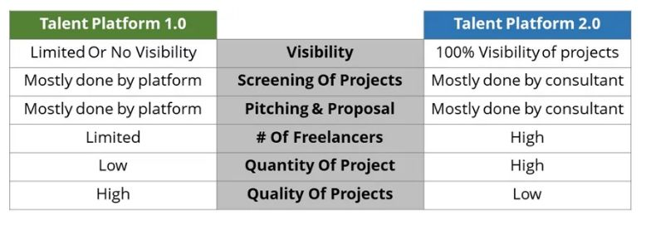

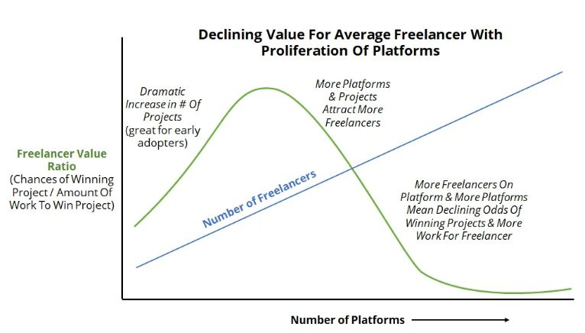 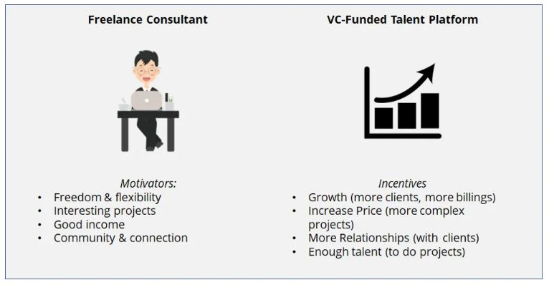

# Competition Analysis

E

very freelance platform in the market, be it large player or a new entrant, the positioning they opt for always makes way to a new entrant in the market. Let’s analyse the strengths and weaknesses of five reputed and dominant freelance platforms in the market.

1. UpWork

Number of registered businesses: 50,00,000

Number of freelancers: 1,20,00,000

Revenue model: 20% for first five jobs and 5% after that

Pros:

Vast number of jobs across various domains

Trusted by millions

Transparent payment methods

High profile value

Cons:

High commission charges

Profile approval is not instantaneous

1. Freelancer.com

Number of registered users: 2,40,00,000

Revenue model: 10% fee

Pros:

A vast number of jobs and easy to find

Easy profile registration

Great for IT sector

Competitions for cash prizes

Cons:

Bid wars

Issues over sharing sensitive information in bidding zones

1. Guru.com

Number of registered businesses: 9,00,000

Number of registered freelancers: 28,00,000

Revenue model: 9% for free tier and 5% for most premium tier (plus premium tier fees)

Pros:

Less competition

Can get paid by four different parameters (recurring, by tasks, by the hour and by the milestone)

Cons:

Account management

1. Fiverr

Number of registered businesses: 8,30,000

Number of registered users: 55,00,000

Revenue model: 20% fee

Pros:

Simple to use and get started

Has a wide range of niches and domains

Ideal for beginners

Cons:

Low rates for projects

1. PeoplePerHour

Number of registered businesses: 10,03,622

Number of registered users: 29,09,437

Revenue model: 20% to 3.5%

Pros:

Good pricing

Great networking opportunity

Portfolio management

Team collaborations

Cons:

Payment usually done only in pounds

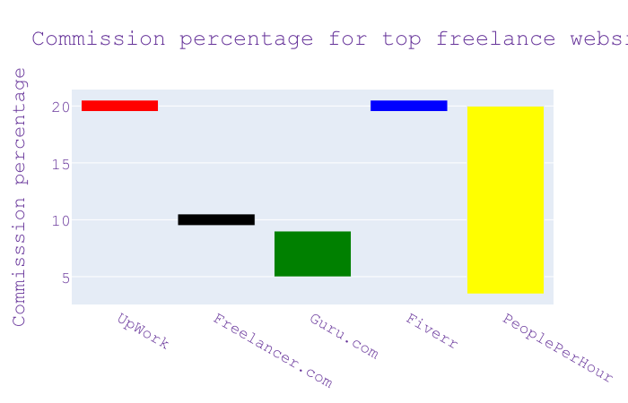

# Relevant Analysis

A freelance website drawing similarities from recruitment websites such as Naukri, Monster and Indeed. During our research, we could find details on how a recommendation engine is helping Indeed to achieve better connections for job seekers.

The searches on Indeed are personalised to job seeker’s experience and can help even the most sophisticated users discover additional jobs that their general search would not have uncovered.

Implementing a recommendation engine, it caused users to see their new recommendations hours faster in remote data centres. From their A/B testing, they have seen a 30% increase in clicks due to the fact that users got newer and relevant recommendations. Also, job recommendations grew from a small MVP contributing to 14% of all clicks that grew from a mere 3% a year before.

# Solution - recommendation engine

M

arketplace earns the platform only when successful deals happen between clients and freelancers and having a well performing recommendation engines ensures to keep the engagement and successful transactions high.

A recommendation engine plays two important roles

1. Project recommendations - ensuring freelancers get the right set of projects recommended thus maximising their chances of winning a project.
2. Freelancer recommendations - ensuring clients get the right set of freelancers recommended thus filtering out the clutter and providing high quality set of freelancers making it easy to finalise the project

The problem of “too many to choose from” can be handled effectively by an automated recommendation engine that understands previous historical data of clients/freelancers, their profiles, their expertise, their interests, their geographical data and their performance over time so as to ensure the clients get recommended a limited set of freelancers that fit bill and vice versa.

# System architecture